Removed deflector from underneath exposing …HE, Condenser, OEM Radiator and Fan /shroud unit
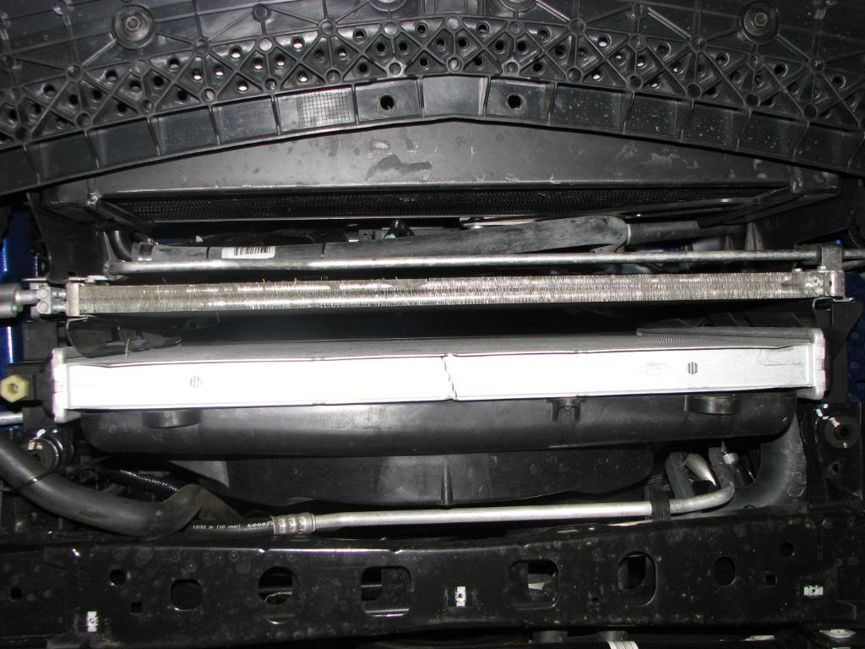

Connected drain hose to drain
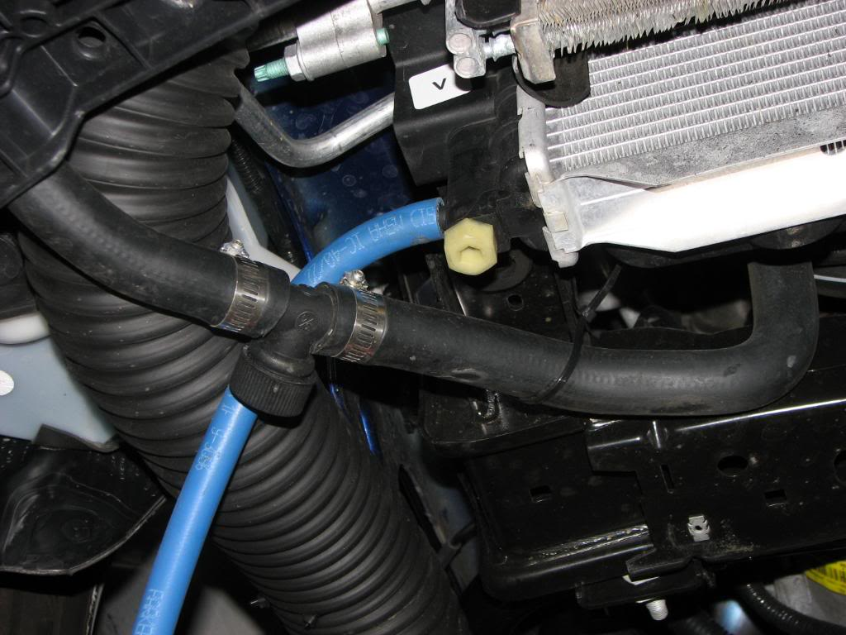

After removing radiator cover and Front upper grille I disconnected Fan wire connector
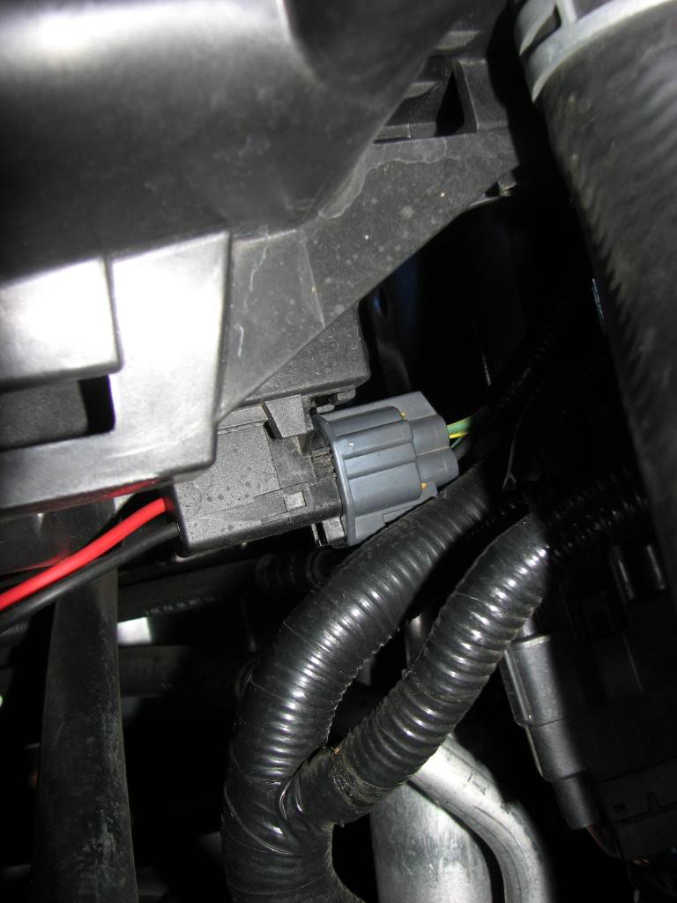

Removed (2) upper bolts holding Fan to Radiator then removed fan assembly
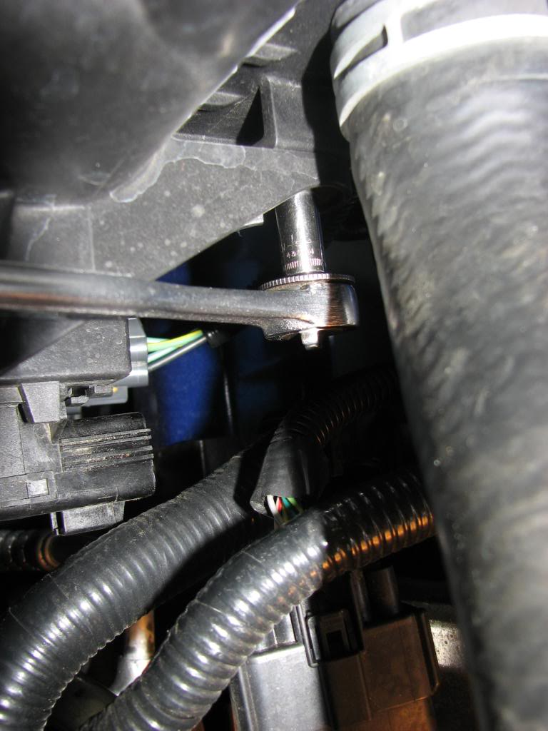

Removed (4) Condenser to Radiator bolts (2 each side)
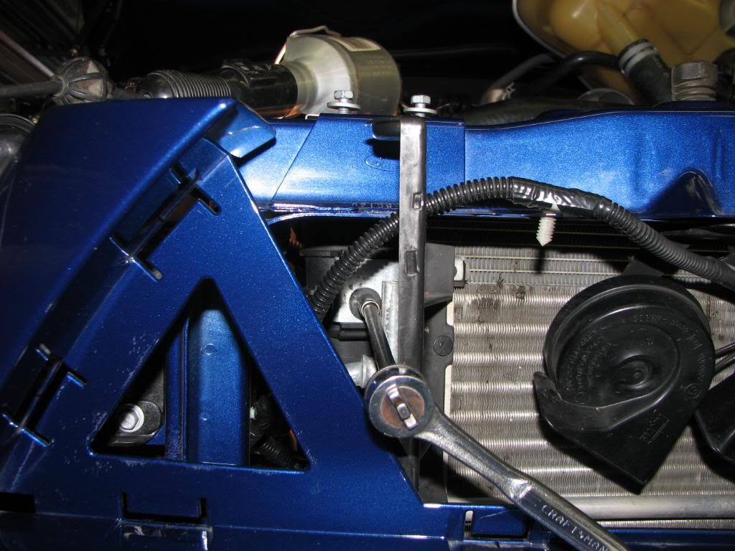

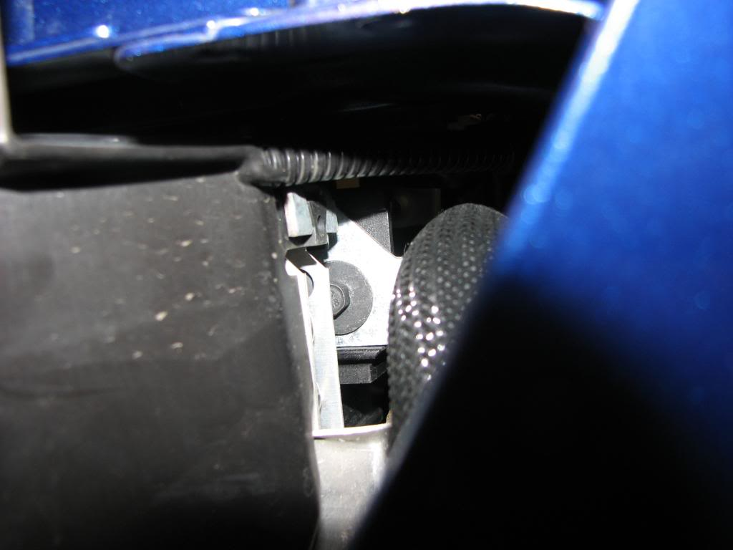

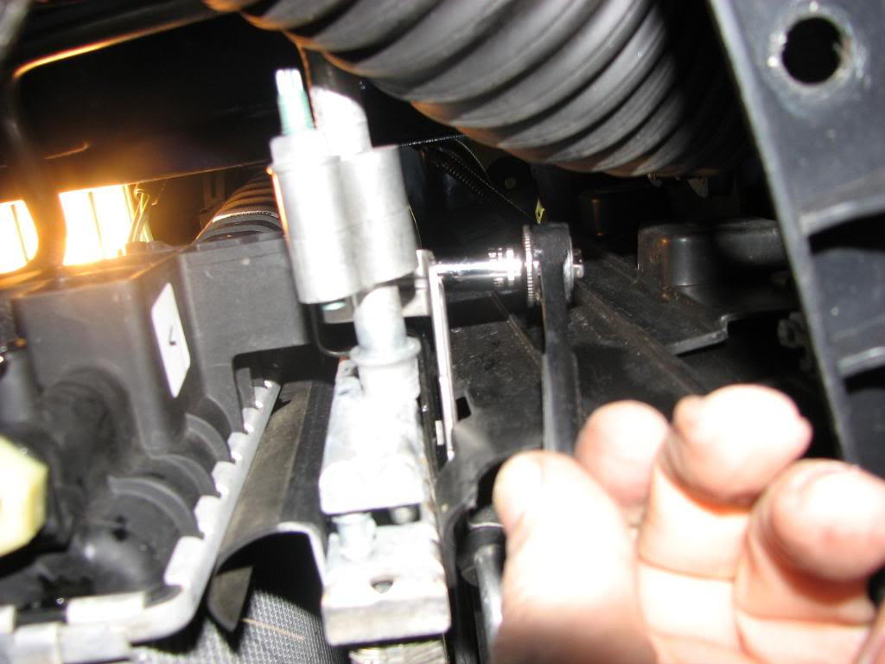

After disconnecting the upper and lower radiator hose’s remove radiator
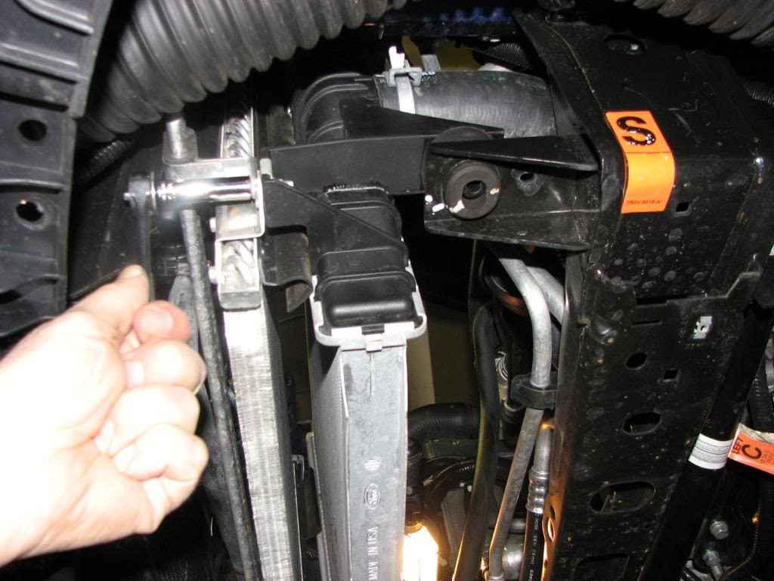

 | Remove and save the nut retaining clips to reutilize on new radiator
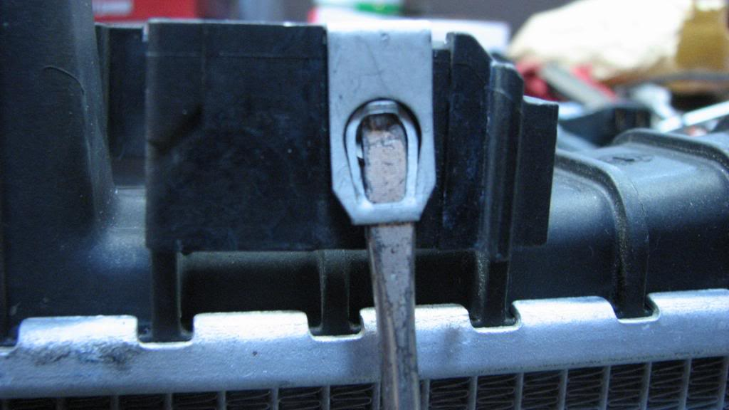 |  | This image has been resized. Click this bar to view the full image. The original image is sized 1024x768 and weights 125KB.

Disconnect ECM wire connectors to provide clearance for installation of new radiator
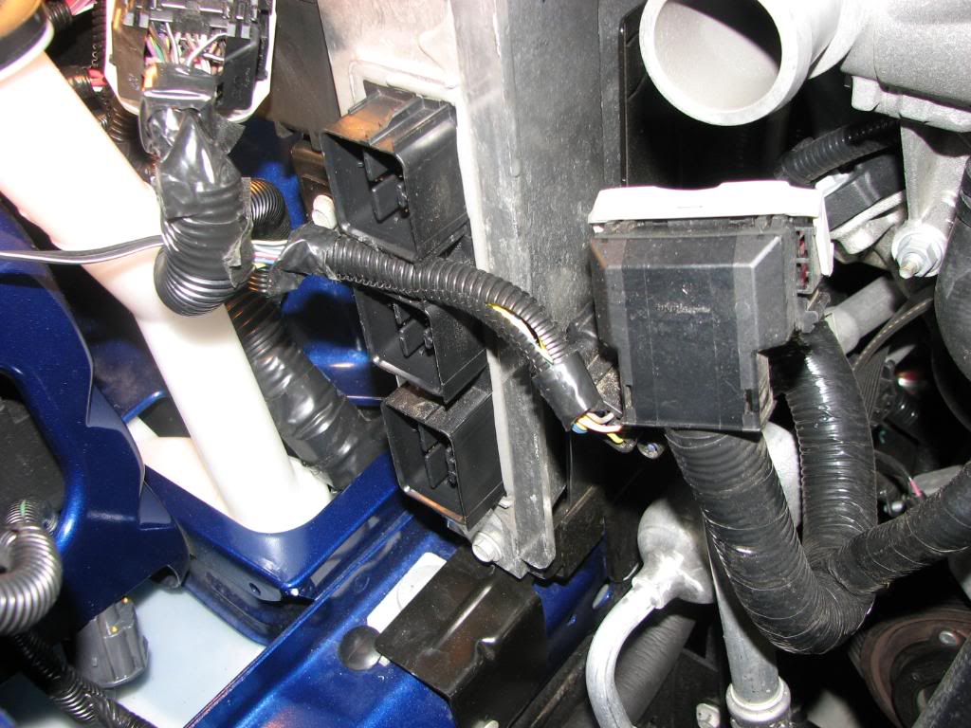
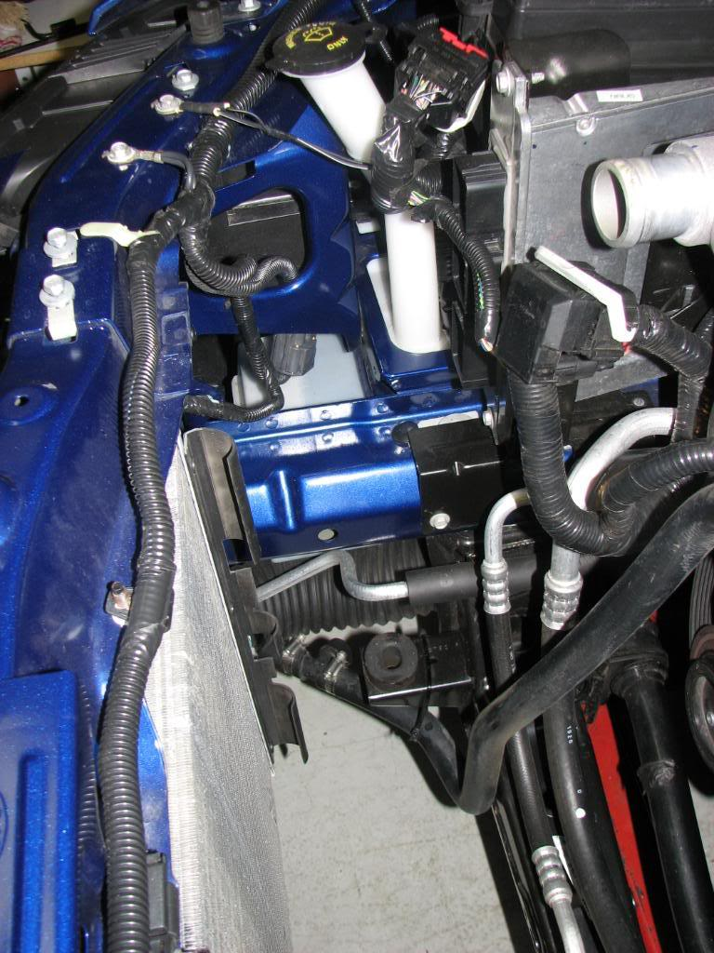

Install new Radiator on angle at first down towards drivers side to clear AC lines
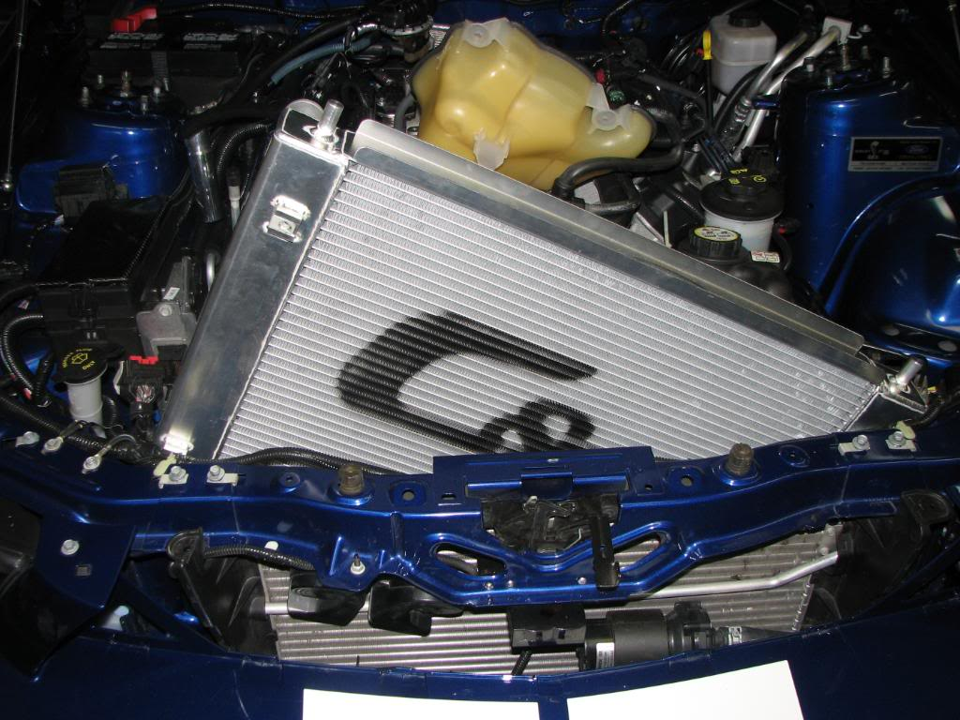

Be sure to fit into rubber mounts at bottom
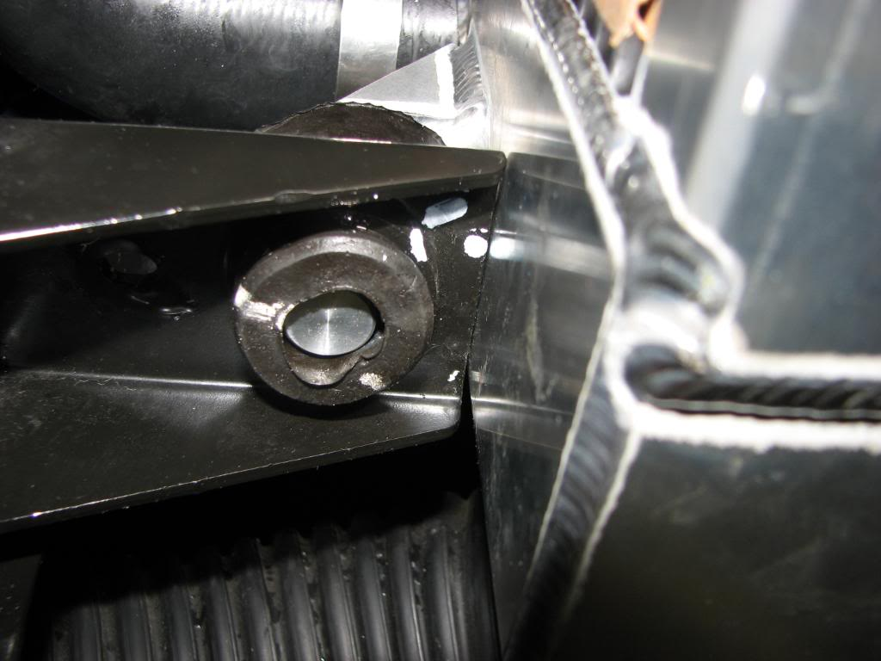

Note: The two upper radiator to condenser front OEM bolts are too long and will puncture the core if used. Be sure to utilize the two bolts provided with the radiator. When attaching radiator at radiator mounting points watch the bolts too make sure that they bolts are not contacting the radiator tanks.

Next cut off approx 1” from lower and upper hose’s and reconnect lower hose using new SS clamp or OEM clamps.
